1. Creating a local repository:

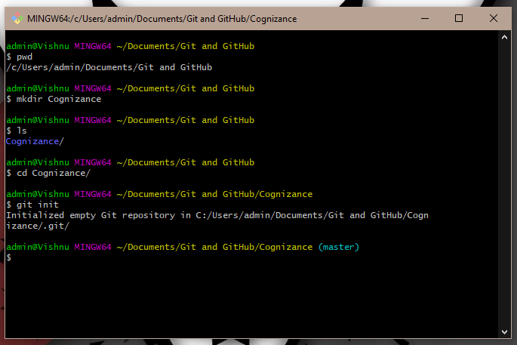

1. git add:

Adds the file to the stage.

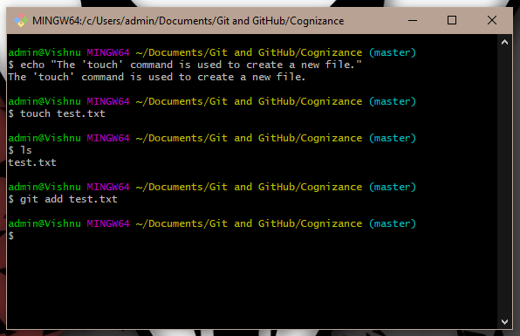

1. git commit:

Puts the staged file on local branch.

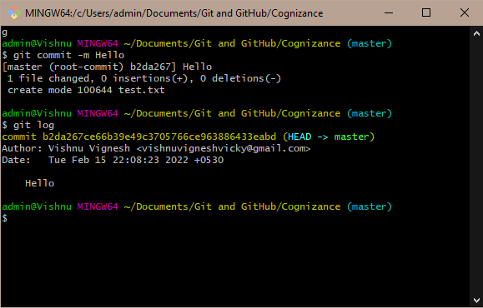

“git log” is used to see a history of all the commits made.

1. git remote:

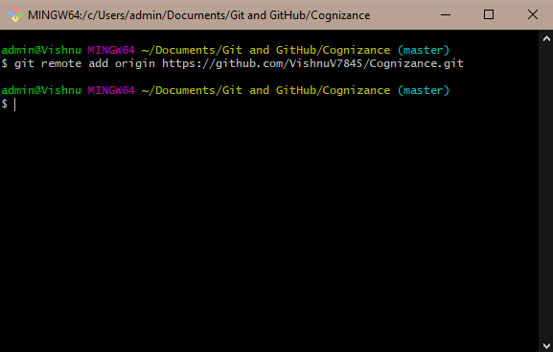

1. git branch:

A pointer to a snapchat of your changes.

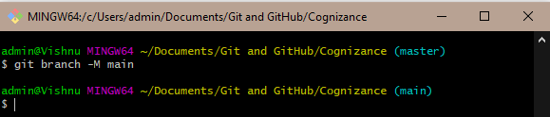

1. git push:

Upload local repository content to a remote repository.

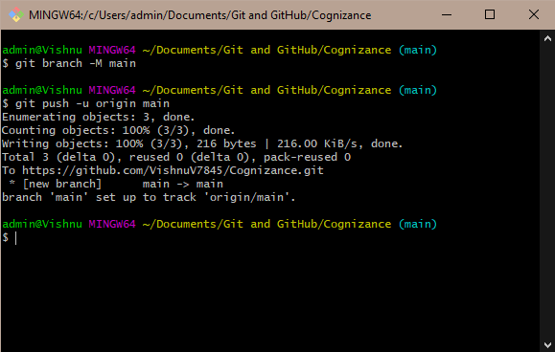

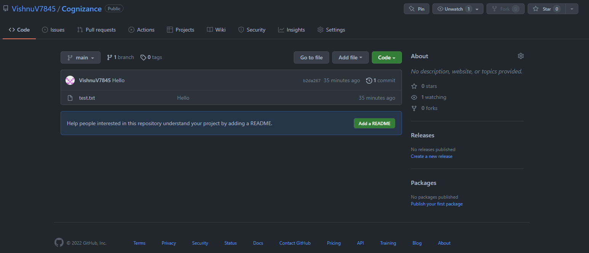

git clone:

Clones a repository.

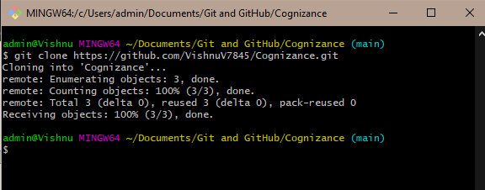

1. git checkout:

Replaces all files.

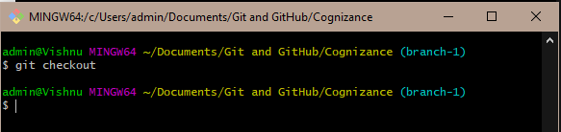

1. git checkout –b

Creates a new branch from the end of a branch.

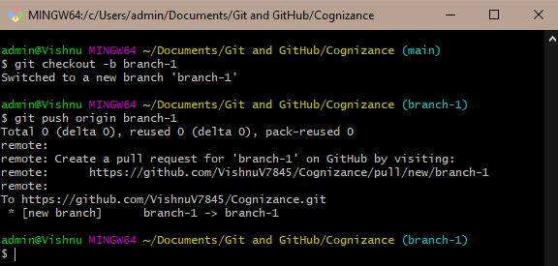

1. git fetch:

Download changes from the remote repository to the local repository.

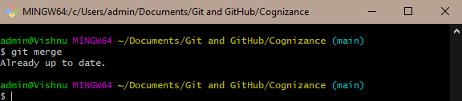

1. git merge:

Merge files from a branch to another.

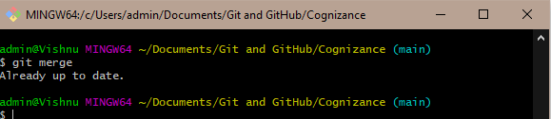

1. git pull:

Fetches changes from the remote repository and merges them.

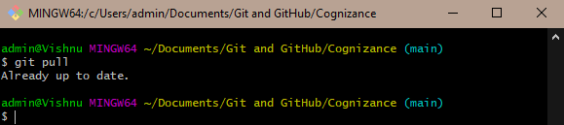

1. git reset:

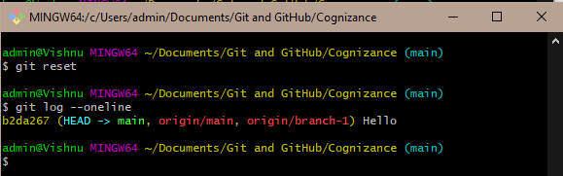

1. git rebase:

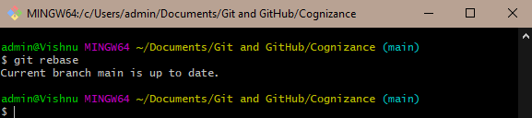

1. git status:

Display current status.

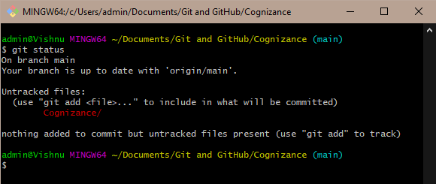

1. git config –list –show-origin

